*Digital Marketing*

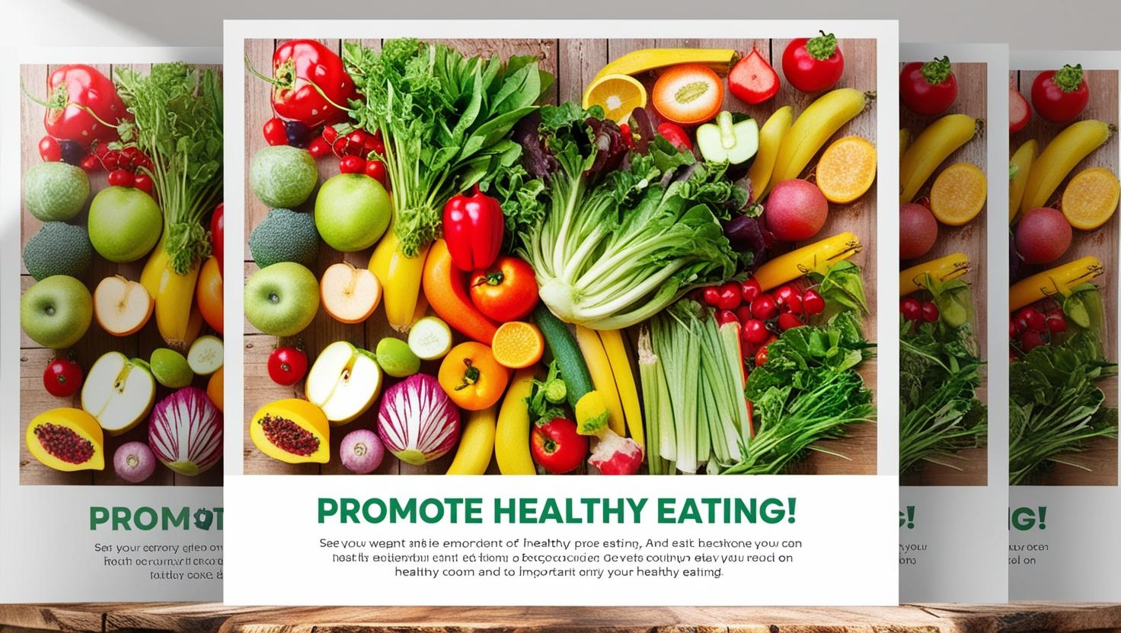

*BY*

*Tamer abdallah Mohamed zalbya*

*Mohamed Gharib Mohamed Aly*

*Ahmed Nagy sedeek*

*Mayada Atef Soliman*

*Ahmed Essam Ali*

*1-Why did we choose the healthy eating promotion project?*

Choosing to promote healthy eating in Egypt is backed by several strong reasons, especially given the presence of **presidential initiatives** that support this direction. These factors enhance the **success potential** of marketing campaigns and increase their impact.

**1. Support from Government and Presidential Initiatives**

Egypt has launched several initiatives aimed at improving public health, such as:

* **The “100 million Healthy Lives” Initiative**, which focuses on early detection of diseases linked to unhealthy diets, such as obesity and diabetes.
* **The “Decent Life” Initiative**, which includes raising awareness about nutrition in rural areas.
* **The School Nutrition Initiative**, which provides healthy meals for children.

These initiatives create an **ideal environment** for promoting healthy eating, as they align with national priorities, making it easier to gain **government support** and **collaborate with health organizations**.

**2. Rising Rates of Food-Related Diseases**

* Egypt is witnessing an increase in **obesity, diabetes, and heart diseases** due to the heavy reliance on unhealthy food.
* **Lack of awareness** about the importance of a balanced diet creates a need for awareness campaigns targeting different age groups.

**3. Lifestyle Changes and Growing Health Awareness**

* There is a **global shift** towards healthy eating, reflected in Egypt’s growing interest in **organic products, diet plans, and fitness trends**.
* The rise of **social media influencers** promoting healthy lifestyles has increased public awareness of **nutrition and its impact on health and beauty**.

**4. The Role of Digital Marketing and Technology**

* **Digital marketing** can be leveraged to promote healthy diets through **social media, mobile applications, and websites**.
* Engaging content can include:
  + **Easy and nutritious recipes** tailored to Egyptian cuisine.
  + **Challenges and interactive campaigns** encouraging people to adopt a healthy lifestyle.

**5. Social and Economic Impact**

* Reducing **healthcare costs** associated with treating diet-related diseases.
* Supporting **local food producers** and encouraging a shift towards **healthier food industries**.

**2-Mission & Vision for Promoting Healthy Eating**

* **Mission Statement:**

**To inspire and empower individuals to make healthier food choices by providing accessible, nutritious, and delicious options while fostering a culture of well-being through education, innovation, and community engagement."**

* **Vision Statement:**

**"To create a world where healthy eating is the norm, not the exception, by making wholesome food affordable, enjoyable, and sustainable for everyone, leading to healthier lives and a better future.**

***3-Main Marketing Campaign Objectives for Promoting Healthy Eating***

1. **Raising Awareness by 100000 in 3 Months About the Importance of Healthy Eating**

**By sharing educational content (videos, infographics, and posts) and tracking engagement metrics like reach and shares.**

1. **Encourage 10,000 People to Try Healthy Recipes in 6 Months**

**Through a motivating followers to share their experiences and interact with posts.**

*Gantt chart*

|  |  |  |  |
| --- | --- | --- | --- |
| **Item** | **Item description** | **prepare** | **Deadline** |
| Project Planning & Management | • Identify the product/service/brand to be marketed. • Define the main objectives of the marketing campaign. • Create a timeline for project phases (Gantt Chart). • Identify digital tools and platforms to be used. • Assign team roles and responsibilities. | Tamer abdallah Mohamed zalbya | 2/24/2025 |
| BCM Review | • Develop a Business Canvas Model for the project. • Conduct a SWOT analysis. • Study the latest digital marketing strategies for the project. • Review techniques used in successful projects. • Analyze digital market trends and their impact on marketing campaigns | Mohamed Gharib Mohamed Aly | 2/24/2025 |
| Requirements Gathering | • Analyze audience behavior across various digital channels. • Identify tools and technologies required for campaign execution. • Conduct interviews and surveys with the target audience to understand user needs. • Create Personas representing the project’s primary users | Mayada Atef Soliman &Ahmed Nagy sedeek | 2/24/2025 |
| System Analysis & Design | • Prepare a digital marketing strategy, including: o Selecting appropriate marketing channels (Social Media, SEO, Email Marketing, Paid Ads). o Developing a content marketing plan (content types and publishing schedule). o Defining Key Performance Indicators (KPIs) to measure campaign success. • Design a prototype for the marketing campaign (Mockups, Wireframes). • Prepare a campaign management plan and execution phases. | Ahmed Essam Ali | 2/24/2025 |
| Implementation | • Create and design marketing content suitable for each digital channel. • Launch the marketing campaign on selected channels. • Implement Search Engine Optimization (SEO) strategies. • Manage audience interaction and respond to comments and messages. | all team | 4/11/2025 |
| Final Presentation & Testing & Reports | Final Presentation, Testing, and Reports • Submit a final report including result analysis. • Suggest improvements for future campaigns based on collected data. • Present the final project, including: o Campaign strategy and objectives. o Performance analysis and achieved results. o Lessons learned . | all team | 4/11/2025 |

* Digital tools
* 1. Social Media Marketing Tools
* Platforms: Facebook, Instagram, snapchat
* Tools:
* Meta Business Suite (for Facebook & Instagram Ads)
* Canva / Adobe Spark (for creating engaging visuals & infographics)

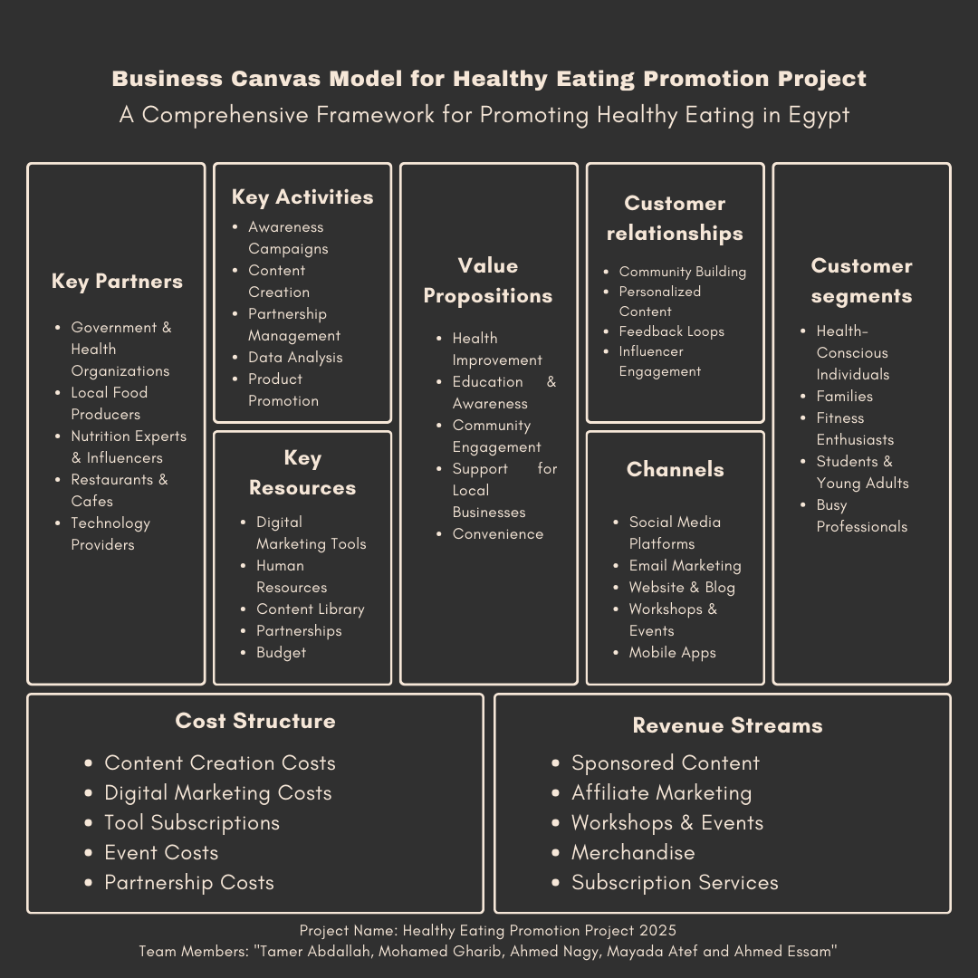

**SWOT Analysis for the Healthy Eating Promotion Project**

| **Category** | **Points** | **Solutions** |
| --- | --- | --- |
| **Strengths** | - Increasing health awareness.  - Availability of diverse healthy food options.  - Government and health organization support.  - Digital platforms for awareness campaigns.  - Rising demand for specialized diets (keto, vegan, gluten-free). | - Leverage social Social Media and influencers.  - Collaborate with health organizations.  - Use storytelling and testimonials to promote benefits. |
| **Weaknesses** | - Higher cost of healthy food.  - Limited awareness in some communities.  - Perceived bland taste of some healthy foods.  - Difficulty in changing long-term eating habits. | - Introduce affordable healthy options.  - Conduct awareness campaigns in schools and media.  - Develop tastier recipes and healthy fast-food alternatives.  - Offer free samples and promotional discounts. |
| **Threats** | - Popularity of cheap fast food.  - Influence of unhealthy food advertising.  - Limited nutritional knowledge among consumers.  - Economic factors affecting purchasing power. | - Compete with fast food by offering quick and healthy alternatives.  - Use engaging digital marketing and educational content.  - Partner with restaurants to introduce healthy menu options. |
| **Opportunities** | - Growing demand for healthy food due to lifestyle diseases.  - Advancements in food technology (e.g., sugar & flour substitutes).  - Government incentives for promoting healthy eating.  - Popularity of health-conscious diets.  - Digital marketing opportunities for reaching a wider audience. | - Invest in R&D for innovative healthy products.  - Engage in partnerships with fitness and wellness industries.  - Create mobile apps for easy access to nutritional information. |

**Digital Marketing Strategy for the Healthy Eating Promotion Project**

**1️-Selecting the Appropriate Marketing Channels**

**Social Media Marketing:**

* Utilize **Facebook, Instagram,**  to engage with the audience.
* Share **engaging content** such as healthy recipes, nutrition tips, and success stories.

**Paid Advertising (PPC - Pay Per Click):**

* Run **Facebook ads** targeting health-conscious individuals.

**Content Scheduling:**

* **3-5 Daily posts** on social media.

**5️-Campaign Management & Execution Plan**

**Campaign Timeline:**

| **Phase** | **Tasks** | **Duration** |
| --- | --- | --- |
| **Research & Analysis** | Market & audience analysis | 2 weeks |
| **Content Creation** | Developing posts, videos, blogs | 3 weeks |
| **Campaign Launch** | Publishing content, running ads | 3-6 months |
| **Monitoring & Evaluation** | Tracking performance & adjustments | Ongoing |

**4️ Creating Personas Representing Core Users**

Personas help define different segments of the target audience, making marketing efforts more personalized.

**Example Personas for the Healthy Eating Promotion Project:**

**Sarah – The Health-Conscious Student**

* **Age:** 21
* **Occupation:** University Student
* **Pain Points:**
  + Struggles with time management and meal prepping.
  + Finds it expensive to eat healthy on a student budget.
* **Goals & Motivations:**
  + Wants quick, easy, and affordable healthy meal options.
  + Seeks to maintain an active lifestyle with minimal effort.
* **Preferred Channels:**
  + **Instagram, TikTok, YouTube** for quick recipe videos and influencer recommendations.
* **Marketing Approach:**
  + Short, engaging **Reels & TikToks** showcasing easy-to-make healthy meals.
  + **Meal-prep challenges** with budget-friendly ingredients.
  + Collaboration with **fitness & nutrition influencers**.

**Ahmed – The Busy Professional**

* **Age:** 35
* **Occupation:** Corporate Manager
* **Pain Points:**
  + Limited time for cooking and meal preparation.
  + Constantly eating out due to a hectic schedule.
* **Goals & Motivations:**
  + Wants **quick and nutritious meals** to support an active lifestyle.
  + Prefers **ready-to-go meal plans** that fit into a busy workday.
* **Preferred Channels:**
  + **Facebook, LinkedIn, Email Newsletters** for structured, informative content.
* **Marketing Approach:**
  + Subscription-based **meal plan recommendations** via email.
  + **Healthy food delivery service partnerships**.
  + Quick **recipe videos for busy schedules**.

**Fatima – The Health-Conscious Mom**

* **Age:** 40
* **Occupation:** Stay-at-home mom
* **Pain Points:**
  + Wants to prepare **healthy meals for her family** but struggles with picky eaters.
  + Concerned about **processed foods and artificial ingredients**.
* **Goals & Motivations:**
  + Learning how to make **nutritious and family-friendly meals**.
  + Ensuring her **kids develop healthy eating habits**.
* **Preferred Channels:**
  + **Facebook Groups, YouTube, Pinterest** for family-focused meal ideas.
* **Marketing Approach:**
  + **Kid-friendly healthy recipes**.
  + **Live cooking sessions** with nutrition experts.
  + Community-driven content like **mom support groups** on Facebook.

**Tamer – The Fitness Enthusiast**

* **Age:** 37
* **Occupation:** Gym Trainer / Fitness Coach
* **Pain Points:**
  + Needs **high-protein, performance-driven meals**.
  + Avoids unhealthy fats, sugar, and processed foods.
* **Goals & Motivations:**
  + **Gaining muscle, improving endurance, and staying fit.**
  + Learning about **supplements and meal timing for performance.**
* **Preferred Channels:**
  + **YouTube, Instagram, Reddit (fitness forums).**
* **Marketing Approach:**
  + **High-protein meal plans & supplement guides.**
  + Collaborations with **fitness influencers & athletes.**
  + **Workout nutrition tips & meal-prep strategies.**